Test Case: tc006_SPX_Dev5_Validacion_Boton_AddNewMenu_Administrador_Menu
Step 1 - Enter username and password and click to button Enter : Credentials Entered
Image file-name: QC_Testing-runTestMultipleTimes-nov. 20 2025, 05 50 03 p. m.

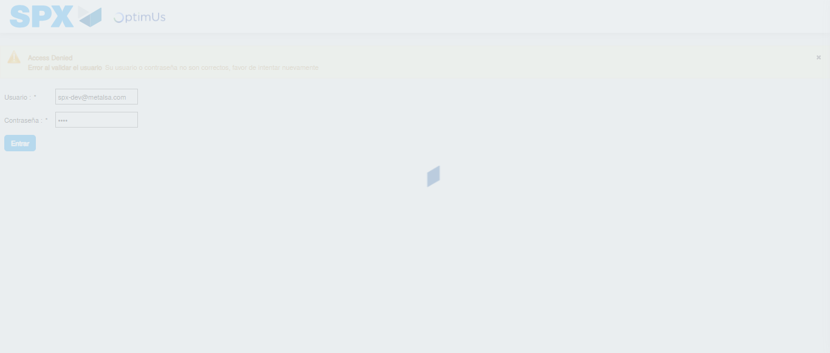Image file-name: QC_Testing-runTestMultipleTimes-nov. 20 2025, 05 50 04 p. m.

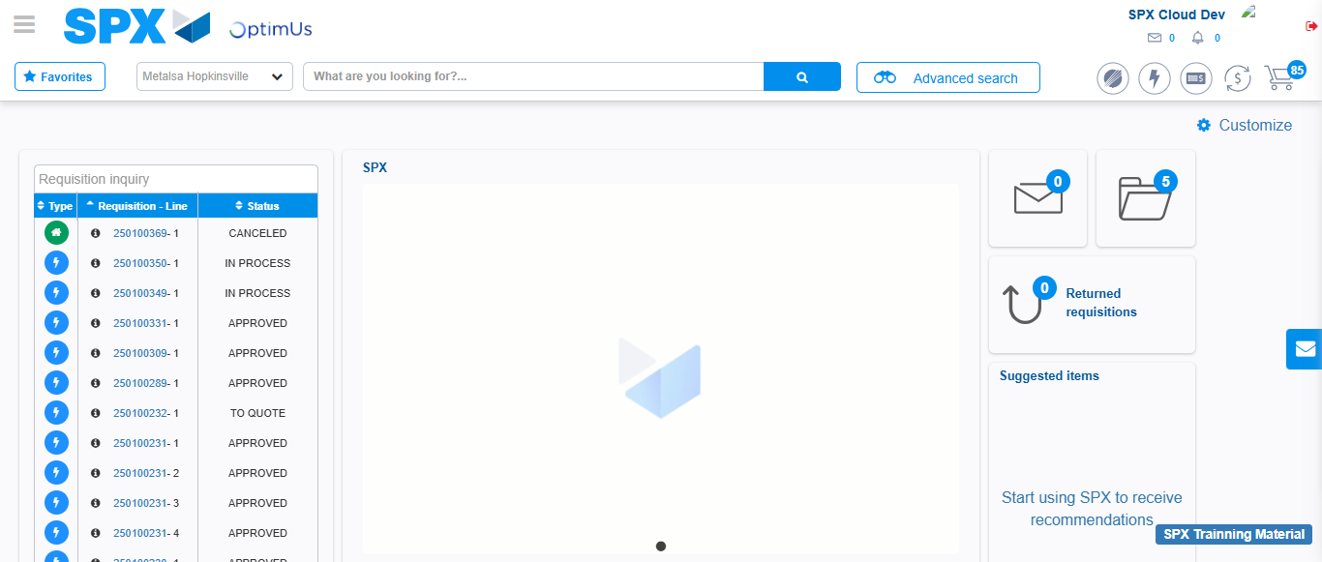Image file-name: QC_Testing-tc001_SPX_Dev5_Validar_Filtro_Campo_MenuName_Administrador_Roles_Menu-nov. 20 2025, 05 50 47 p. m.

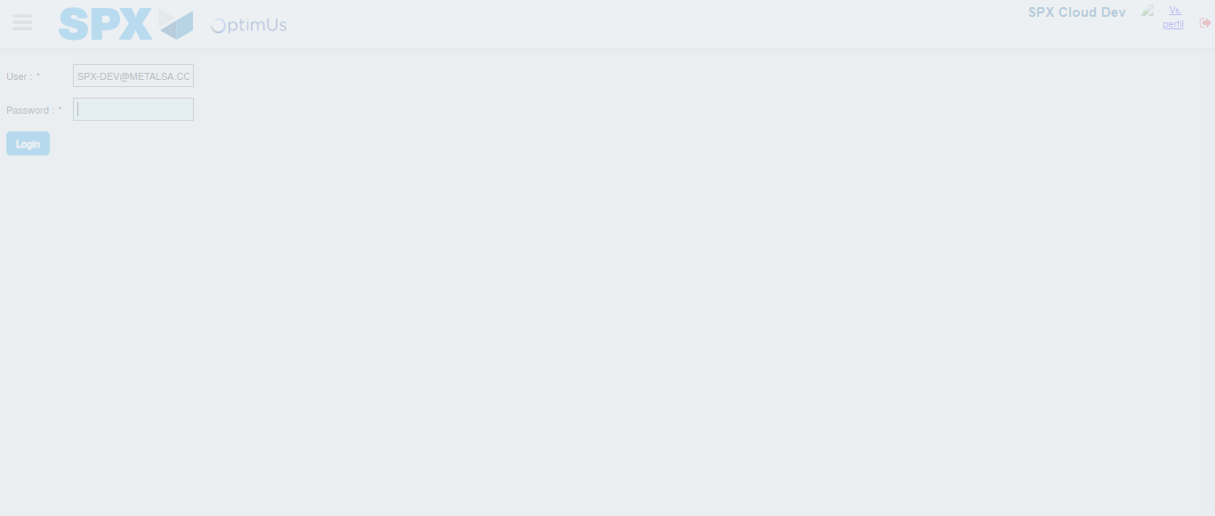Image file-name: QC_Testing-tc002_SPX_Dev5_Validar_Filtro_Campo_URLPath_Administrador_Roles_Menu-nov. 20 2025, 05 51 12 p. m.

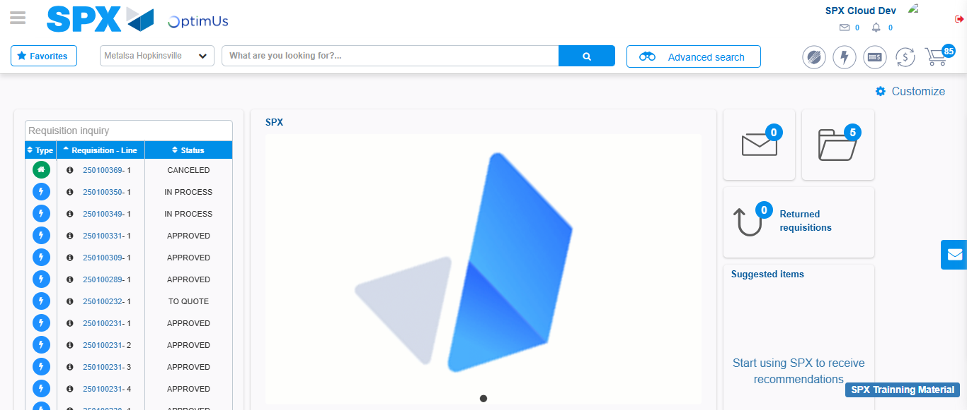Image file-name: QC_Testing-tc003_SPX_Dev5_Validar_Funcionalidad_Botones_Add_Remove_Administrador_Roles_Menu-nov. 20 2025, 05 51 28 p. m.

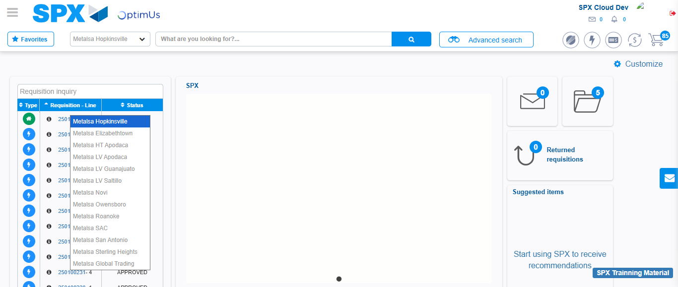Image file-name: QC_Testing-tc004_SPX_Dev5_Validacion_Filtro_Campo_MenuName_Administrador_Menu-nov. 20 2025, 05 52 07 p. m.

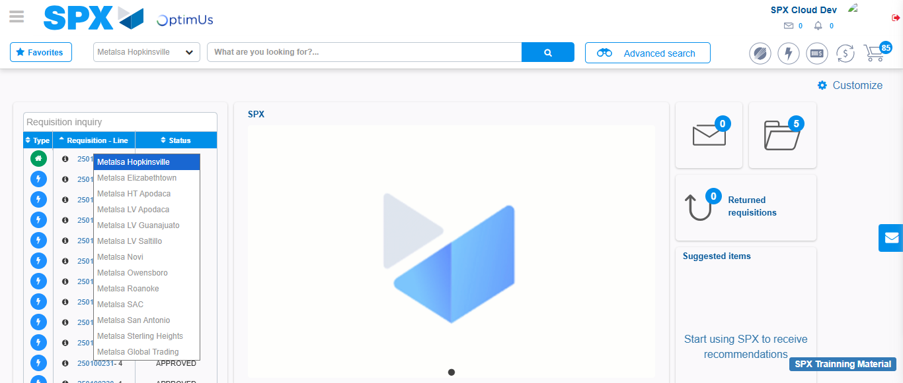Image file-name: QC_Testing-tc005_SPX_Dev5_Validacion_Filtro_Campo_URLPath_Administrador_Menu-nov. 20 2025, 05 52 38 p. m.

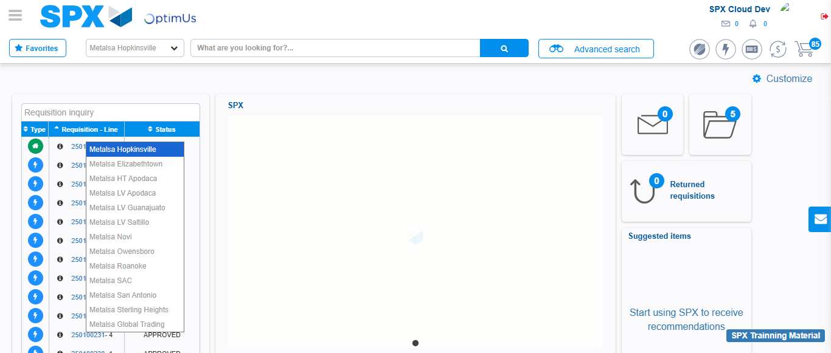Image file-name: QC_Testing-tc006_SPX_Dev5_Validacion_Boton_AddNewMenu_Administrador_Menu-nov. 20 2025, 05 53 11 p. m.

Step 2 - Select to UEN and Access to Administrador Roles Menu: UEN Correctly selected and Correct access
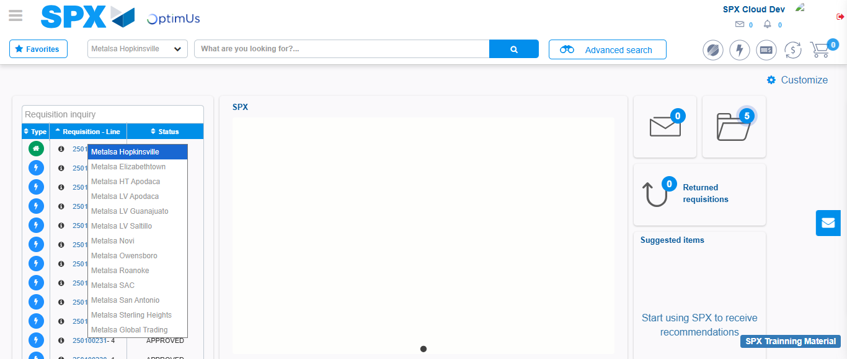Image file-name: QC_Testing-runTestMultipleTimes-nov. 20 2025, 05 50 14 p. m.

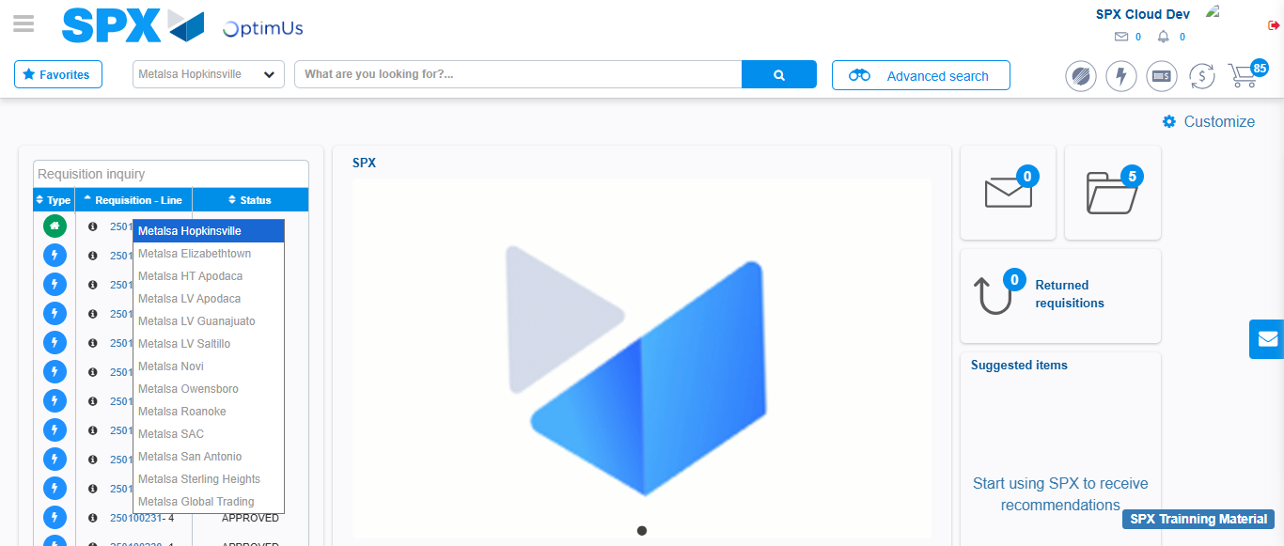Image file-name: QC_Testing-runTestMultipleTimes-nov. 20 2025, 05 50 25 p. m.

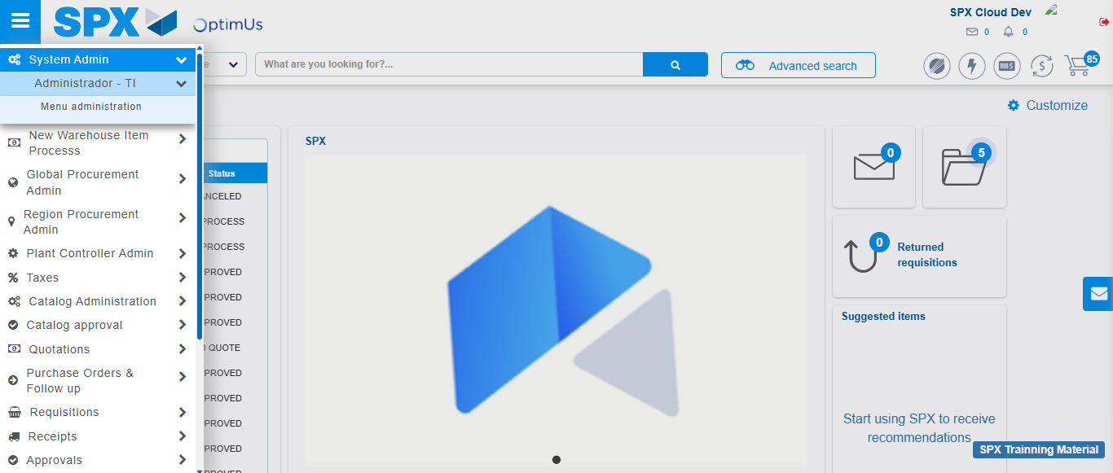Image file-name: QC_Testing-runTestMultipleTimes-nov. 20 2025, 05 50 26 p. m.

Image file-name: QC_Testing-runTestMultipleTimes-nov. 20 2025, 05 50 30 p. m.

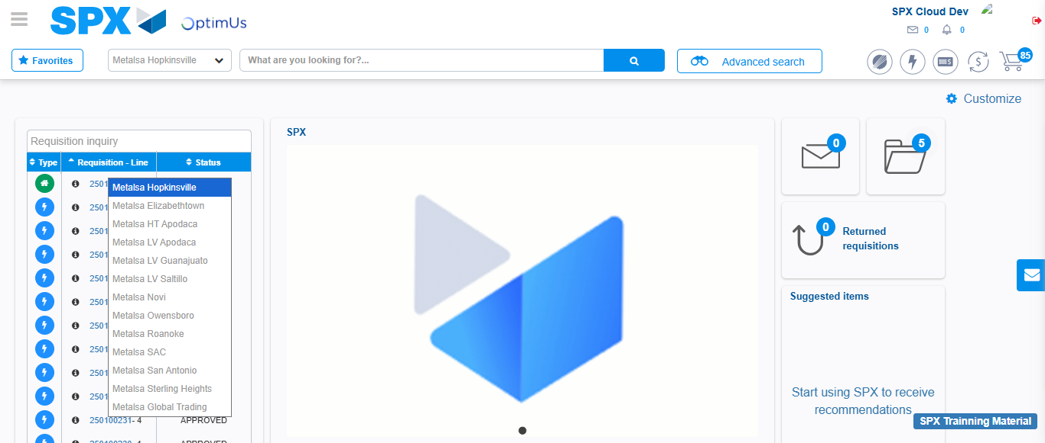Image file-name: QC_Testing-tc001_SPX_Dev5_Validar_Filtro_Campo_MenuName_Administrador_Roles_Menu-nov. 20 2025, 05 50 48 p. m.

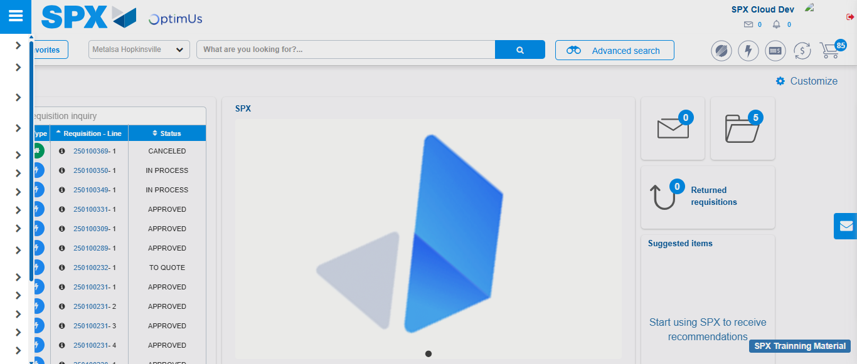Image file-name: QC_Testing-tc001_SPX_Dev5_Validar_Filtro_Campo_MenuName_Administrador_Roles_Menu-nov. 20 2025, 05 50 59 p. m.

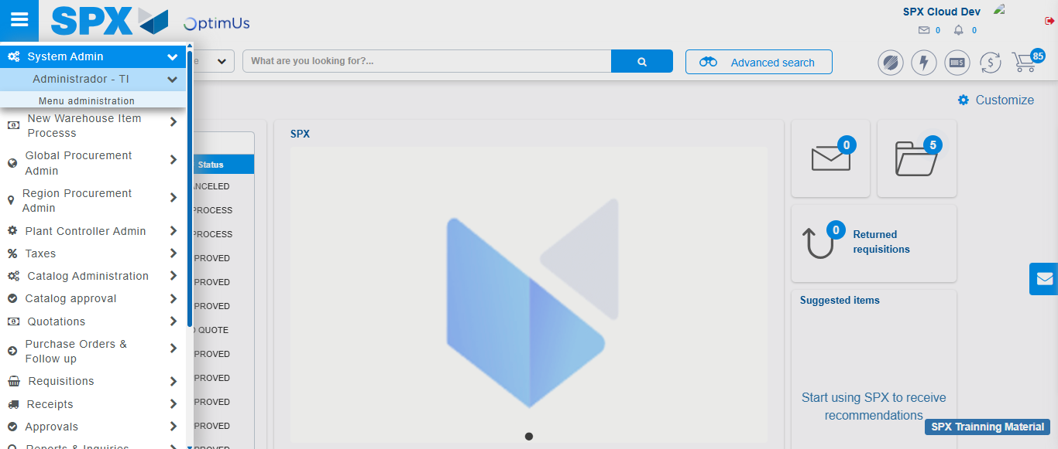Image file-name: QC_Testing-tc001_SPX_Dev5_Validar_Filtro_Campo_MenuName_Administrador_Roles_Menu-nov. 20 2025, 05 51 00 p. m.

Image file-name: QC_Testing-tc001_SPX_Dev5_Validar_Filtro_Campo_MenuName_Administrador_Roles_Menu-nov. 20 2025, 05 51 03 p. m.

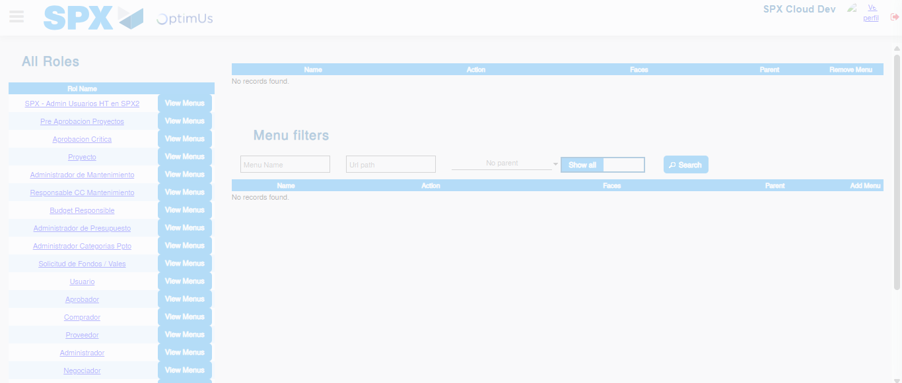Image file-name: QC_Testing-tc001_SPX_Dev5_Validar_Filtro_Campo_MenuName_Administrador_Roles_Menu-nov. 20 2025, 05 51 04 p. m.

Image file-name: QC_Testing-tc003_SPX_Dev5_Validar_Funcionalidad_Botones_Add_Remove_Administrador_Roles_Menu-nov. 20 2025, 05 51 28 p. m.

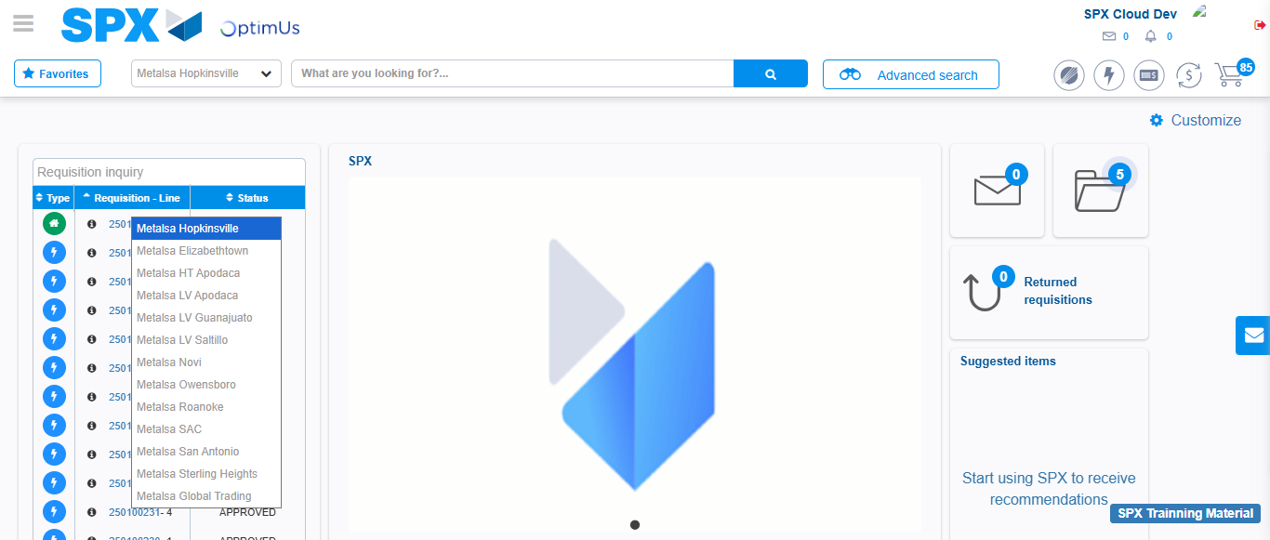Image file-name: QC_Testing-tc003_SPX_Dev5_Validar_Funcionalidad_Botones_Add_Remove_Administrador_Roles_Menu-nov. 20 2025, 05 51 29 p. m.

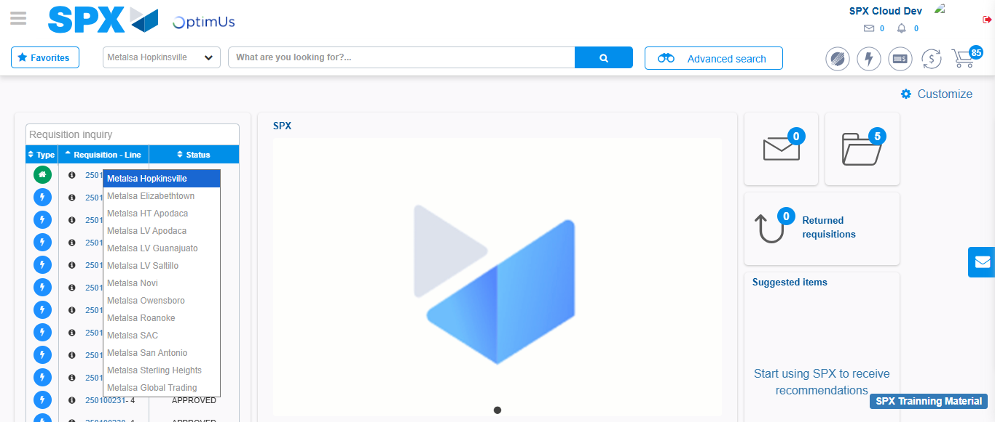Image file-name: QC_Testing-tc003_SPX_Dev5_Validar_Funcionalidad_Botones_Add_Remove_Administrador_Roles_Menu-nov. 20 2025, 05 51 39 p. m.

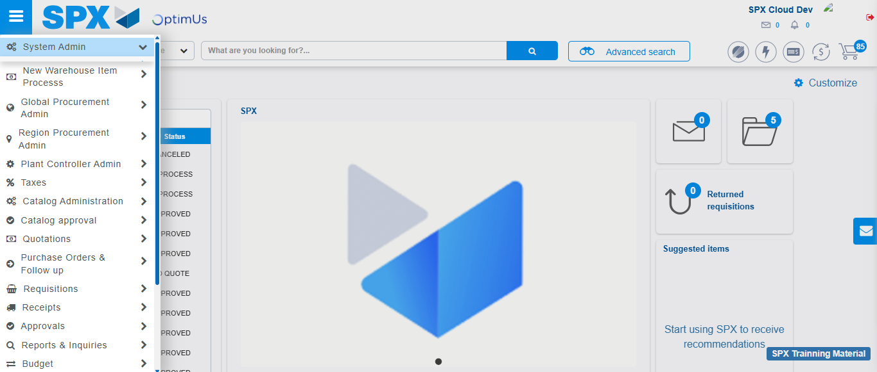Image file-name: QC_Testing-tc003_SPX_Dev5_Validar_Funcionalidad_Botones_Add_Remove_Administrador_Roles_Menu-nov. 20 2025, 05 51 40 p. m.

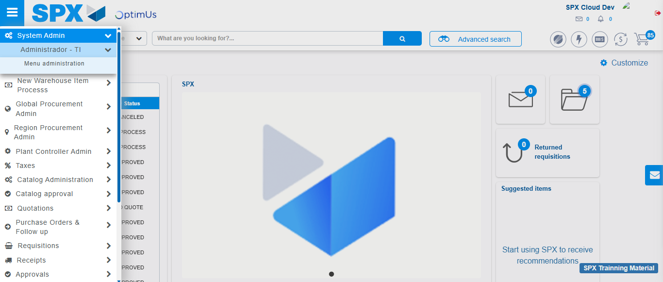Image file-name: QC_Testing-tc003_SPX_Dev5_Validar_Funcionalidad_Botones_Add_Remove_Administrador_Roles_Menu-nov. 20 2025, 05 51 41 p. m.

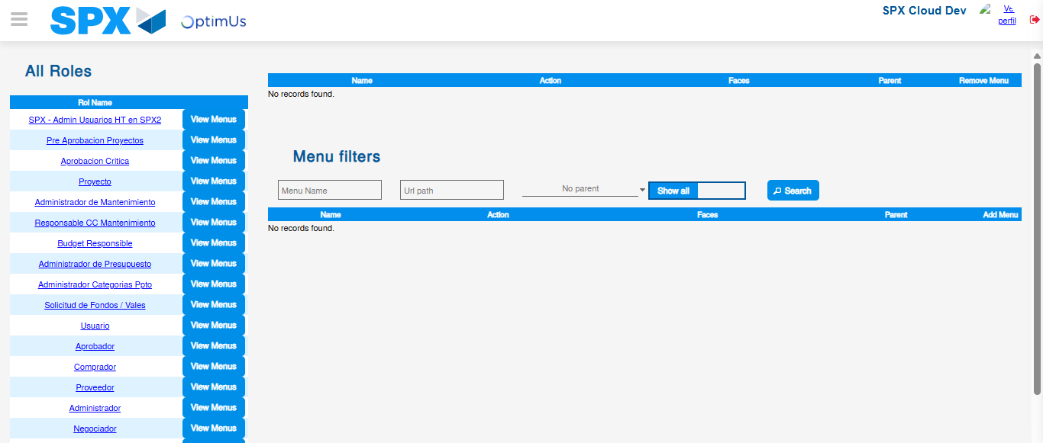Image file-name: QC_Testing-tc003_SPX_Dev5_Validar_Funcionalidad_Botones_Add_Remove_Administrador_Roles_Menu-nov. 20 2025, 05 51 42 p. m.

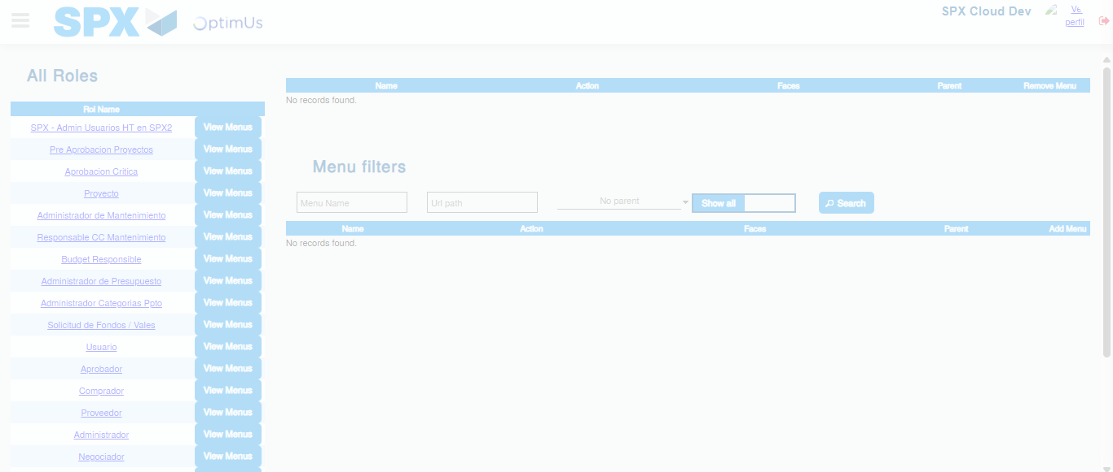Image file-name: QC_Testing-tc003_SPX_Dev5_Validar_Funcionalidad_Botones_Add_Remove_Administrador_Roles_Menu-nov. 20 2025, 05 51 43 p. m.

Image file-name: QC_Testing-tc004_SPX_Dev5_Validacion_Filtro_Campo_MenuName_Administrador_Menu-nov. 20 2025, 05 52 07 p. m.

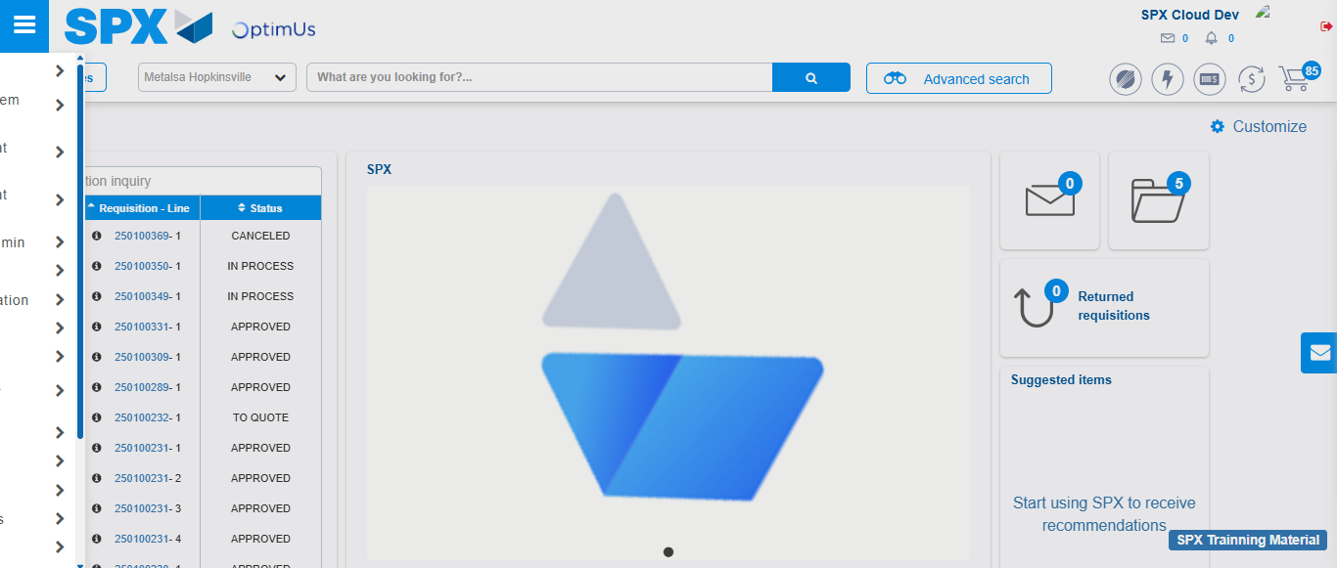Image file-name: QC_Testing-tc004_SPX_Dev5_Validacion_Filtro_Campo_MenuName_Administrador_Menu-nov. 20 2025, 05 52 18 p. m.

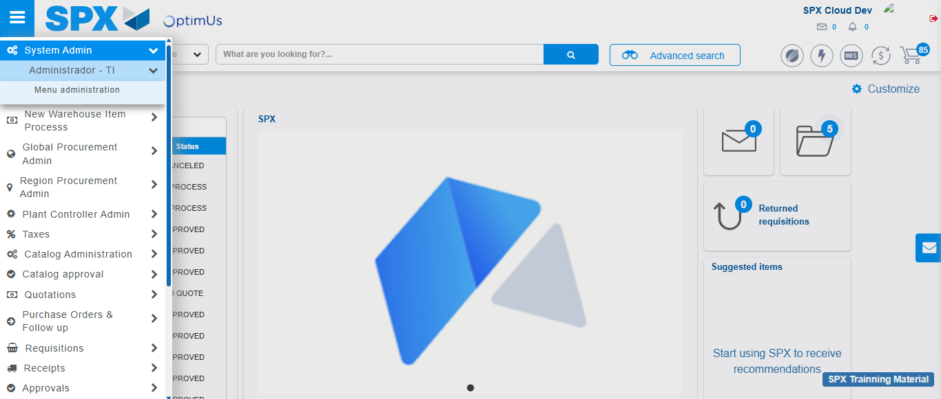Image file-name: QC_Testing-tc004_SPX_Dev5_Validacion_Filtro_Campo_MenuName_Administrador_Menu-nov. 20 2025, 05 52 19 p. m.

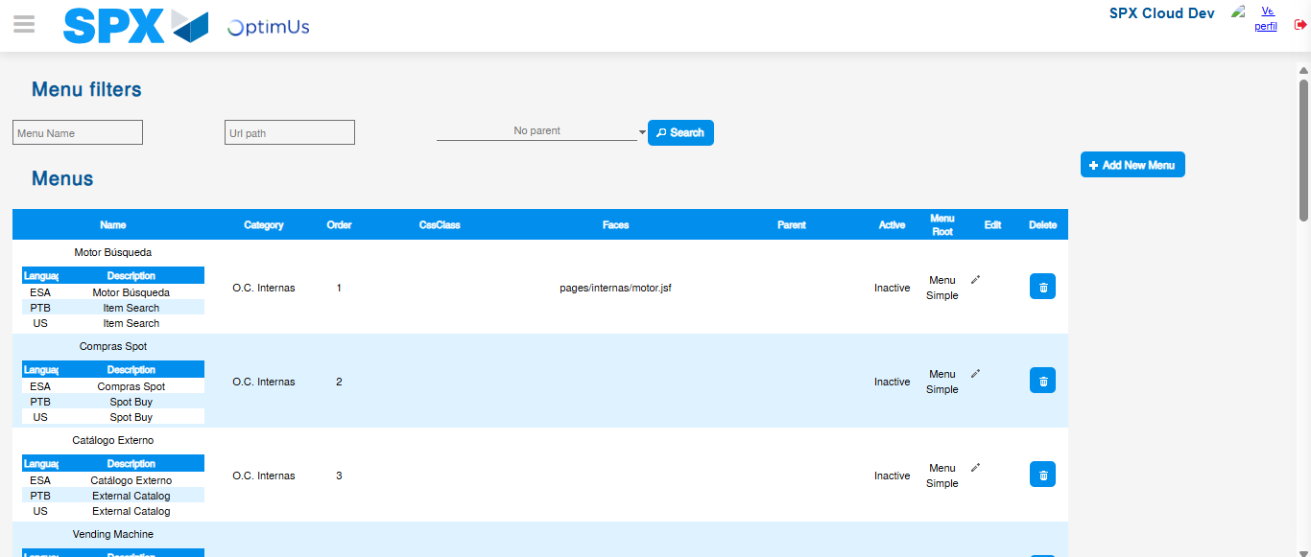Image file-name: QC_Testing-tc004_SPX_Dev5_Validacion_Filtro_Campo_MenuName_Administrador_Menu-nov. 20 2025, 05 52 21 p. m.

Image file-name: QC_Testing-tc005_SPX_Dev5_Validacion_Filtro_Campo_URLPath_Administrador_Menu-nov. 20 2025, 05 52 38 p. m.

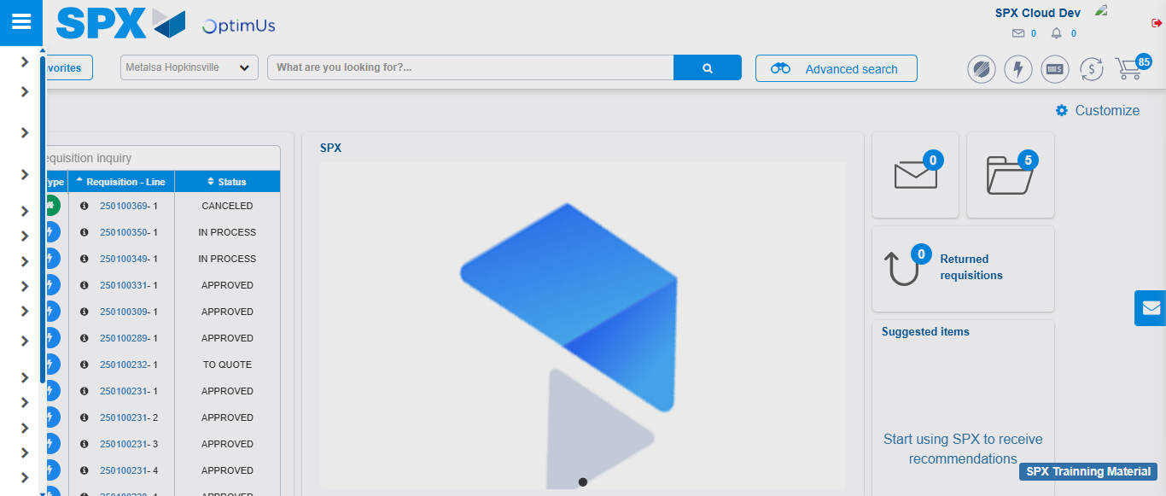Image file-name: QC_Testing-tc005_SPX_Dev5_Validacion_Filtro_Campo_URLPath_Administrador_Menu-nov. 20 2025, 05 52 49 p. m.

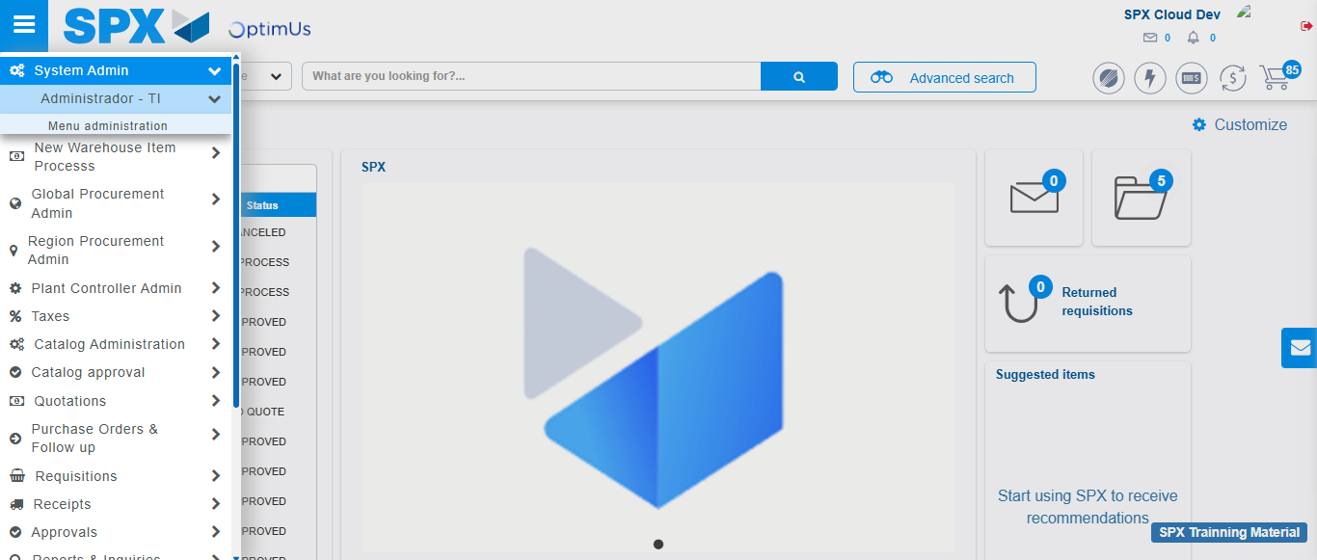Image file-name: QC_Testing-tc005_SPX_Dev5_Validacion_Filtro_Campo_URLPath_Administrador_Menu-nov. 20 2025, 05 52 50 p. m.

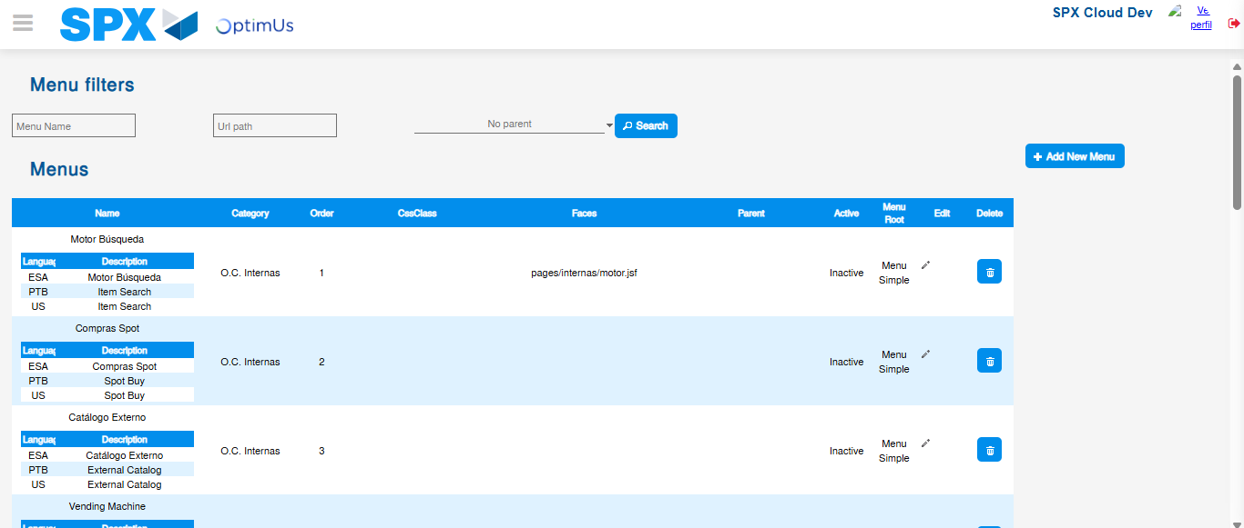Image file-name: QC_Testing-tc005_SPX_Dev5_Validacion_Filtro_Campo_URLPath_Administrador_Menu-nov. 20 2025, 05 52 52 p. m.

Image file-name: QC_Testing-tc006_SPX_Dev5_Validacion_Boton_AddNewMenu_Administrador_Menu-nov. 20 2025, 05 53 11 p. m.

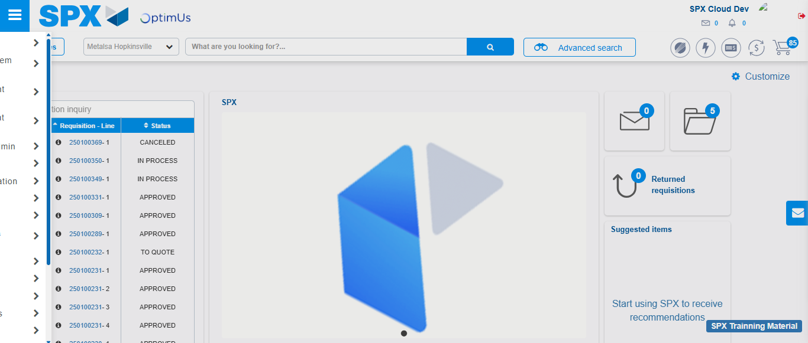Image file-name: QC_Testing-tc006_SPX_Dev5_Validacion_Boton_AddNewMenu_Administrador_Menu-nov. 20 2025, 05 53 22 p. m.

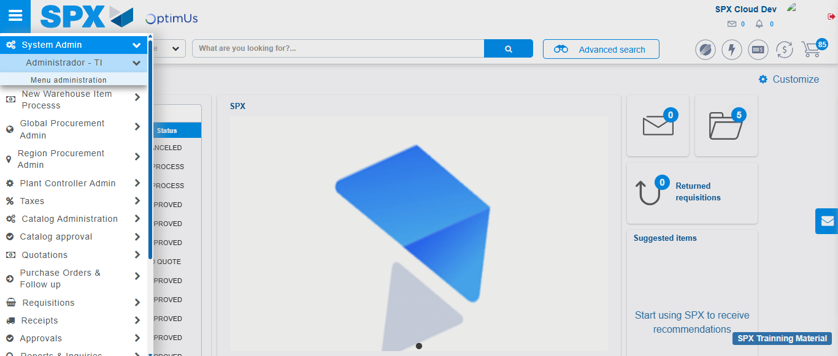Image file-name: QC_Testing-tc006_SPX_Dev5_Validacion_Boton_AddNewMenu_Administrador_Menu-nov. 20 2025, 05 53 23 p. m.

Image file-name: QC_Testing-tc006_SPX_Dev5_Validacion_Boton_AddNewMenu_Administrador_Menu-nov. 20 2025, 05 53 26 p. m.

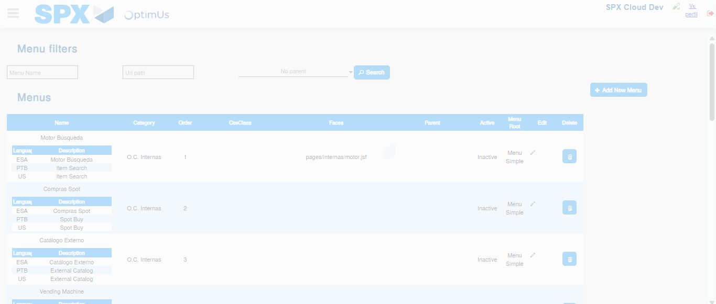Image file-name: QC_Testing-tc006_SPX_Dev5_Validacion_Boton_AddNewMenu_Administrador_Menu-nov. 20 2025, 05 53 27 p. m.

Step 3 - Perform a search with the URL Path filter: Successful search
Image file-name: QC_Testing-tc004_SPX_Dev5_Validacion_Filtro_Campo_MenuName_Administrador_Menu-nov. 20 2025, 05 52 21 p. m.

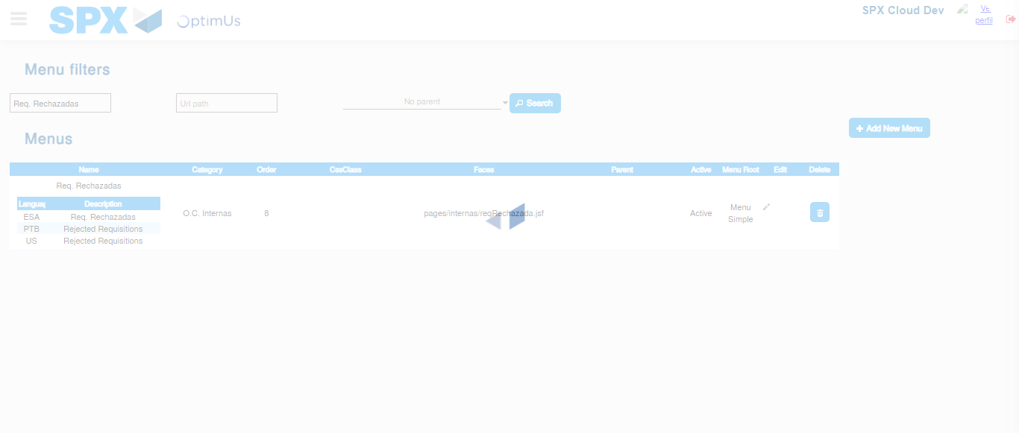Image file-name: QC_Testing-tc004_SPX_Dev5_Validacion_Filtro_Campo_MenuName_Administrador_Menu-nov. 20 2025, 05 52 22 p. m.

Image file-name: QC_Testing-tc005_SPX_Dev5_Validacion_Filtro_Campo_URLPath_Administrador_Menu-nov. 20 2025, 05 52 52 p. m.

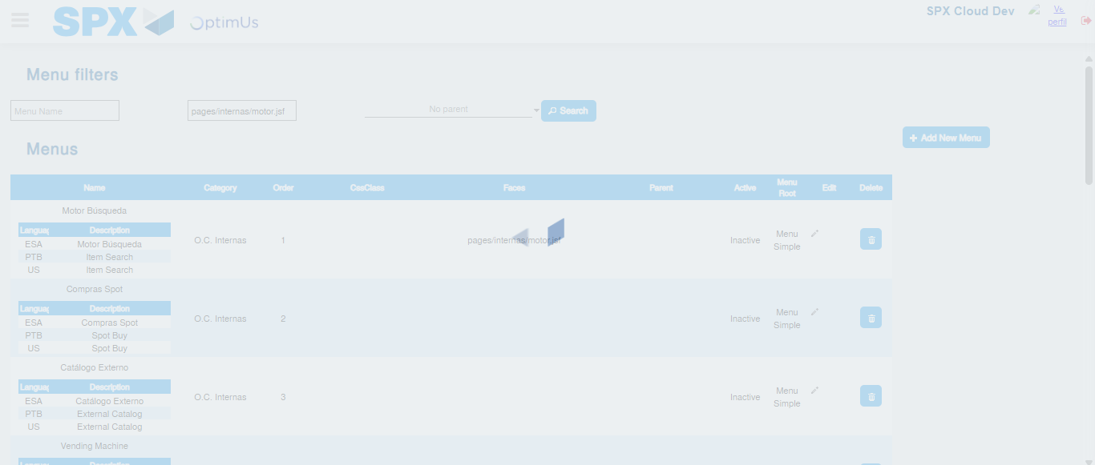Image file-name: QC_Testing-tc005_SPX_Dev5_Validacion_Filtro_Campo_URLPath_Administrador_Menu-nov. 20 2025, 05 52 53 p. m.

Image file-name: QC_Testing-tc006_SPX_Dev5_Validacion_Boton_AddNewMenu_Administrador_Menu-nov. 20 2025, 05 53 27 p. m.

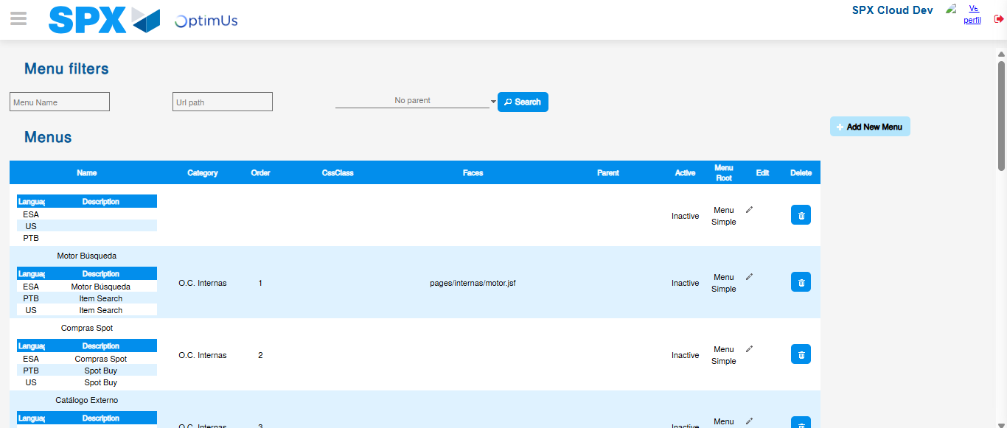Image file-name: QC_Testing-tc006_SPX_Dev5_Validacion_Boton_AddNewMenu_Administrador_Menu-nov. 20 2025, 05 53 30 p. m.

